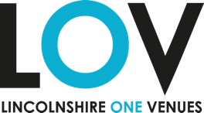

ReInvent Application Form

Name of group or individual applying
Contact details of main contact from organisation
Name
Email Address
Telephone

Tell us a bit about yourself or your group
Tell us about how you connect with your community

What would you like to do?
What have you done to consult others from your community?

Who will be involved?
Who will come to the event?

When will it take place?
How will you spend the money? Please include a rough budget.

The deadline for applications is 12 noon on Monday 18 October.

